FLOWCHART

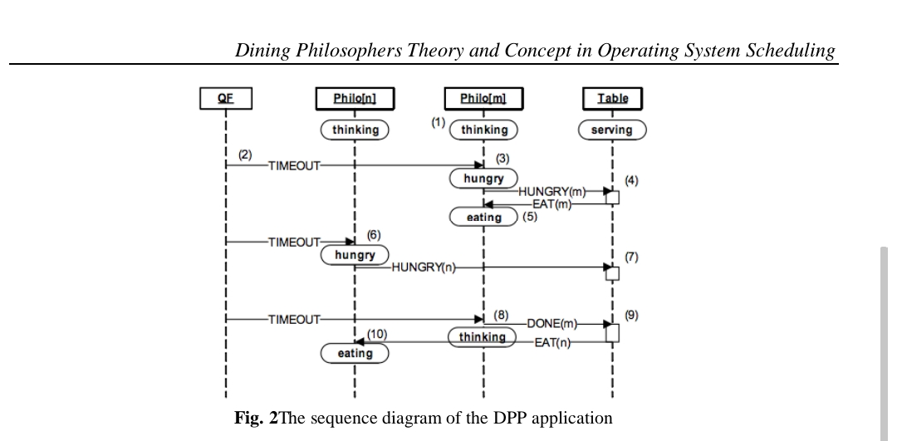

The Explanation to the above Flowchart is given in the following steps;

• Each Philosopher active object starts in the “thinking” state. Upon the entry to this state, the Philosopher arms a one-shot time event to terminate the thinking.

• The QF framework posts the time event (timer) to Philosopher[m].

• The Table active object finds out that the forks for Philosopher[m] are available and grants it the permission to eat by publishing the EAT(m) event.

• The permission to eat triggers the transition to “eating” in Philosopher[m]. Also, upon the entry to “eating”, the Philosopher arms its one-shot time event to terminate the eating.

• The Philosopher[n] receives the TIMEOUT event, and behaves exactly as Philosopher[m], that is, transitions to “hungry” and posts HUNGRY(n) event to the Table active object.

• This time, the Table active object finds out that the forks for Philosopher[n] are not available, and so it does not grant the permission to eat. Philosopher[n] remains in the “hungry” state.

• The Table active object accounts for free forks and checks whether any direct neighbors of Philosopher[m] are hungry. Table posts event EAT(n) to Philosopher[n].

• The permission to eat triggers the transition to “eating” in Philosopher[n].